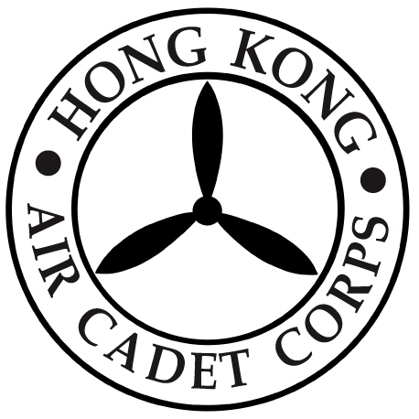
HONG KONG AIR CADET CORPS

NOMINATION FOR MEMBERS OF THE EXECUTIVE BOARD 2019/20

I hereby propose the following Member of the Corps eligible for election under the Articles of Association to be Member of the Executive Board for 2019/20.

PROPOSER’S NAME:

PROPOSER’S SIGNATURE:

SECONDER’S NAME:

SECONDER’S SIGNATURE:

Acceptance of nomination by the nominee:

- Member
Nominee’s Signature:_____________________________
Nominee’s Name:___________________

Please return this form, when completed, to the Honorary Secretary (c/o AM) not later than 1800 hours, Friday, 6 December 2019.

